**UNIVERSITY OF THE SOUTHERN CARIBBEAN**

**P.O. BOX 175, PORT OF SPAIN**

**Task 1**

An Assignment

Presented in Partial Fulfillment

Of the Requirements for the Course

CPTR252: COMPUTER SCIENCE II

INSTRUCTOR: Fayola St. Bernard

By

Dwayne Headley

6 October 2023

Approval ……………………………

**Introduction**

The library management system is a program put in place to allow librarians to manage the library’s inventory, check out and return items, and keep track of library members.

**Classes**

**LibraryItem (Base Class):**

Attributes:

* Item ID
* Title
* Author
* pubDate - Publication Date
* availStat - Availability Status (Boolean)

Methods:

* Constructor to initialize attributes
* Accessors and mutators for attributes
* checkOut() - Method to mark the item as checked out
* return() - Method to mark the item as returned

**Book (Derived from LibraryItem):**

Attributes:

* bookISBN (International Standard Book Number)

Methods:

* Constructor to initialize ISBN and call the parent constructor
* Accessor and mutator for ISBN

**Magazine (Derived from LibraryItem):**

Attributes:

* magazineID – Identification for the magazine

Methods:

* Constructor to initialize Issue Number and call the parent constructor
* Accessor and mutator for Issue Number

**Journal (Derived from LibraryItem):**

Attributes:

* journalID or journalISSN – Identification for the journal

Methods:

* Constructor to initialize journalID and call the parent constructor
* Accessor and mutator for journalID

**Digital Media (Derived from LibraryItem):**

Attributes:

* mediaFormat - (e.g., DVD, Blu-ray, eBook)

Methods:

* Constructor to initialize mediaFormat and call the parent constructor
* Accessor and mutator for mediaFormat

**LibraryMember:**

Attributes:

* memberID
* memberName
* memberContact
* memberBooks - List of Checked-out Items (an array or list of LibraryItem references)

Methods:

* Constructor to initialize attributes
* Accessors and mutators for all attributes
* addItem() - Method to add an item to the list of checked-out items
* removeItem() - Method to remove an item from the list of checked-out items
* searchItem() - Method to search for an item from the list of checked-out items

**Relationships:**

**Association (LibraryMember and LibraryItem):**

* Multiplicity: Many Library Members can check out many Library Items, and each Library Item can be checked out by many Library Members.

**Composition (LibraryMember and LibraryItem):**

* A Library member “has a” collection of Library Items.

**Inheritance (Book, Magazine, Journal, DigitalMedia to LibraryItem):**

* Description: Each object (Book, Magazine, Journal, DigitalMedia to LibraryItem) inherit attributes from the base class LibraryItems.

**Class Diagram**

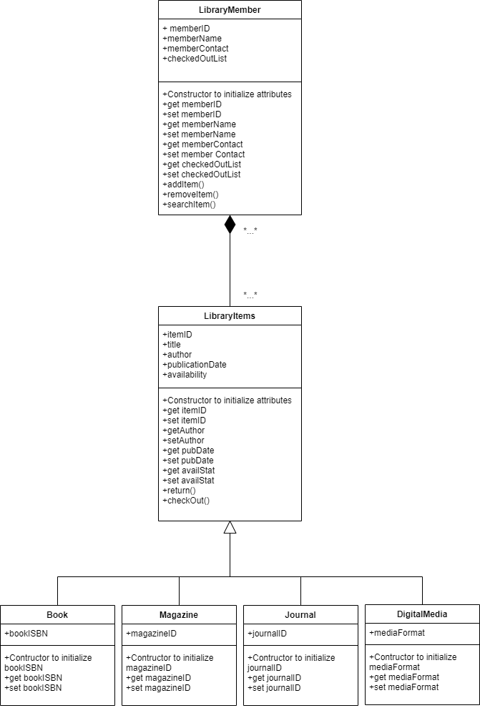

**Assumptions**

While it was not discussed above, I assumed that the system would have different user roles; such as the librarians (administrators) and customers (library members). Librarians are meant to have more additional access to the system as opposed to the customers.